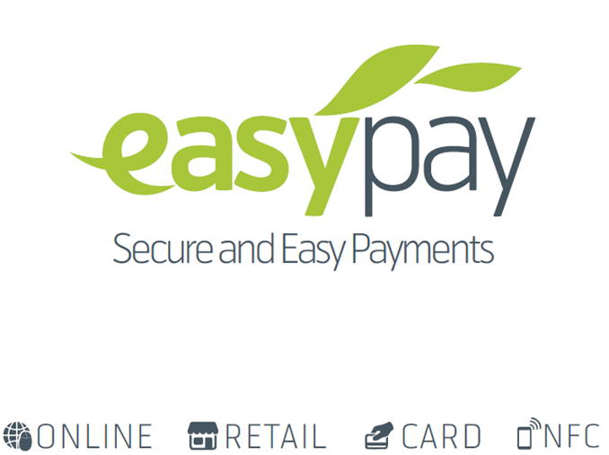

**Easypay**

**Merchant Integration Guide**

**Plugin Integration E-Commerce Cart**

**(WORDPRESS)**

Table of Contents

Introduction 3

Steps for Integration 4

Basic Step 4

Integrating Easypay Payment Method 4

Integrating IPN feature 5

# Introduction

Easypay integration plugin for Wordpress platform gives you the ability to integrate with Easypay Online Payment System. Easypay Online Payment System is an electronic payment solution that enables internet users to make financial transaction online. The plugin can be easily and seamlessly integrated into an existing website, web store or any of your online presence that is built using Wordpress framework. This plugin contains the enablement of following two facilities that are provided by Easypay Online Payment System:

1. Redirection Based Easypay Integration
2. Support for IPN feature

This Easypay plugin for Wordpress based websites is built upon woocommerce 3.2.6.

# Steps for Integration

## Basic Step

For the enablement of the module firstly the merchant will have to upload the zip folder that is provided by Telenor POC. Access Admin Panel, go to Plugins-> Add New-> Upload Plugin



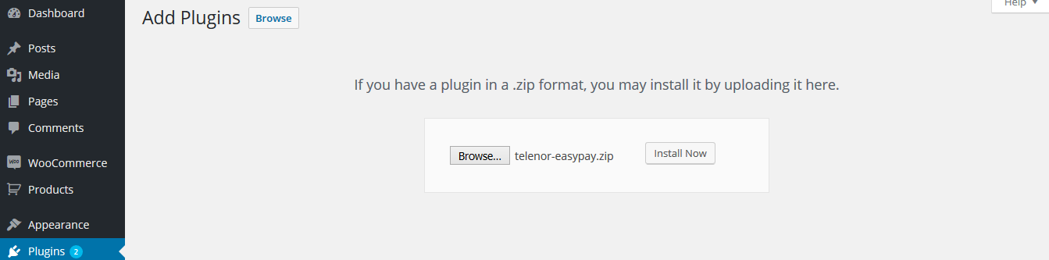

## Integrating Easypay Payment Method

Now the plugin is deployed on your server. Now you need to follow below steps to activate your Easypay Plugin. Access Admin Panel, go to Plugins, Easypay Plugin will appear in the list activate it. After successful activation of plugin an Easypay Panel will appear, go to Easypay Panel.

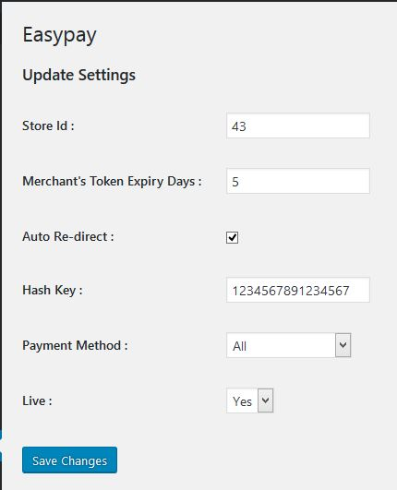

Following variables are configurable in this panel that needs to be changed according to environment you are using:

1. **StoreId**: The Easypay Merchant Store Id that is provided to you by Telenor POC, this will be configured based on the environment you are using.
2. **Merchant’s Token Expiry Days**: Number of days the merchant want its OTC token to be expired in, this will be an integer value.
3. **Auto-Redirect**: Either the merchant wants to redirect its customer to it's website at the end of order or not. If yes, then the customer placing the order will be redirected after 10 seconds to the final checkout screen.
4. **Hash-Key**: Allows the merchant to send the request to Easypay in an encrypted package, this will prevent any kind of data tempering by any external entity. The merchant needs to copy here the same key which is defined in Easypay Merchant Portal.
5. **Payment Method**: The method of payment (Credit Card, Mobile Account, Over the Counter or all three) the merchant wants to use for payments.
6. **Live**: Allows the merchant to switch between staging and production environment. Please select No to test Easypay, orders will be routed to staging environment and select Yes for production environment.

After configuring the above mentioned variables Easypay payment method is enabled in your E-Commerce platform of Wordpress.

You are now ready to test the checkout flow of Easypay Payment Method.

## Integrating IPN feature

The IPN feature is by default enabled after the enablement of Easypay Payment Method, the merchant just need to configure the URL in the OPS Merchant Portal. The Easypay IPN URL for the merchant is as follows:

<http://host:port/wordpressHome/wp-content/plugins/telenor-easypay/easypayIPN.php>

<https://easypaystg.easypaisa.com.pk/easypay-merchant/faces/pg/site/Login.jsf>